Introduction to Machine Learning
Machine learning (ML) allows computers to learn and make decisions without being explicitly programmed. It involves feeding data into algorithms to identify patterns and make predictions on new data. It is used in various applications like image recognition, speech processing, language translation, recommender systems, etc. In this article, we will see more about ML and its core concepts.
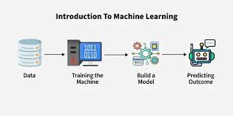
Machine learning (ML) is a subfield of artificial intelligence (AI) that enables computers to learn from data, identify patterns, and make decisions without being explicitly programmed for every specific task. By analyzing large datasets, ML models—such as linear regression, decision trees, or neural networks—improve their accuracy over time.
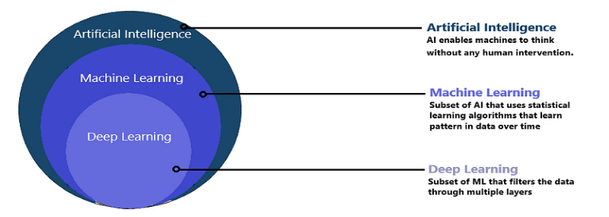
Benefits of Machine Learning
- Enhanced Efficiency and Automation: ML automates repetitive tasks, freeing up human resources for more complex work. This leads to faster, smoother processes and higher productivity.
- Data-Driven Insights: It can analyze large amounts of data to identify patterns and trends that might be missed by people and help businesses make better decisions.
- Improved Personalization: It customizes user experiences by tailoring recommendations and ads based on individual preferences.
- Advanced Automation and Robotics: It helps robots and machines to perform complex tasks with greater accuracy and adaptability. This is transforming industries like manufacturing and logistics.
Challenges of Machine Learning
- Data Bias and Fairness: ML models learn from training data and if the data is biased, model’s decisions can be unfair so it’s important to select and monitor data carefully.
- Security and Privacy Concerns: Since it depends on large amounts of data, there is a risk of sensitive information being exposed so protecting privacy is important.
- Interpretability and Explainability: Complex ML models can be difficult to understand which makes it difficult to explain why they make certain decisions. This can affect trust and accountability.
- Job Displacement and Automation: Automation may replace some jobs so retraining and helping workers learn new skills is important to adapt to these changes.
*Machine learning Applications:
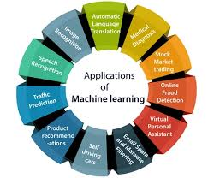
1. Image Recognition
Machine Learning algorithms are used to identify and classify objects in images. It is widely used in face recognition systems, medical image analysis (X-ray, MRI scans), and surveillance systems.

2. Speech Recognition
ML enables machines to understand and convert human speech into text. Applications include voice assistants (Siri, Alexa), call-center automation, and voice-controlled devices.

3. Spam Detection
Machine Learning models analyze email content and user behavior to classify messages as spam or non-spam. It improves accuracy over time by learning from new data.

4. Recommendation Systems
ML analyzes user preferences and behavior to recommend products, movies, or music. Popular examples include Netflix movie suggestions, Amazon product recommendations, and Spotify playlists.

5. Fraud Detection
Banks and financial institutions use ML to detect unusual transaction patterns. It helps in identifying credit card fraud, online payment fraud, and identity theft in real time.

6. Medical Diagnosis
Machine Learning assists doctors by predicting diseases based on patient data. It is used in diagnosing cancer, heart disease, diabetes, and in drug discovery.

7. Self-Driving Cars
Autonomous vehicles use ML to detect lanes, traffic signs, pedestrians, and obstacles. The system learns from driving data to make safe driving decisions.

8. Natural Language Processing (NLP)
ML helps machines understand and process human language. It is used in chatbots, language translation, sentiment analysis, and text summarization.

9. Predictive Analytics
Machine Learning predicts future outcomes based on historical data. It is used in weather forecasting, stock market prediction, sales forecasting, and demand planning.

10. Customer Segmentation
ML groups customers based on purchasing behavior, preferences, and demographics. Businesses use this to improve marketing strategies and customer satisfaction.
*History of Machine Learning :
1. Foundations Before Machine Learning (1940–1950)
The roots of Machine Learning lie in mathematics, statistics, neuroscience, and early computing. In 1943, Warren McCulloch and Walter Pitts proposed the first artificial neuron model, inspired by the human brain. This model showed how logical operations could be performed using neural structures.
In 1950, Alan Turing published the paper “Computing Machinery and Intelligence”, introducing the Turing Test, which became a benchmark for machine intelligence.

2. Emergence of Machine Learning (1950s)
In 1959, Arthur Samuel formally introduced the term Machine Learning. He developed a computer program that played checkers and improved its performance through experience. This work demonstrated that machines could learn from data rather than relying only on explicit instructions, marking a turning point in artificial intelligence.

3. Early Growth and Algorithm Development (1960s)
During the 1960s, researchers focused on creating algorithms that allowed machines to recognize patterns. Important developments included:
- Perceptron (Frank Rosenblatt) for pattern recognition
- Linear regression and classification models
- Nearest neighbor algorithms
Despite early success, these models were limited by computational power and small datasets.

4. Challenges and First AI Winter (1970s)
High expectations led to disappointment when ML systems failed to handle complex real-world problems. The limitations of perceptrons, highlighted by Minsky and Papert, resulted in reduced funding and interest. This period became known as the first AI Winter, slowing progress significantly.

5. Knowledge-Based Systems and Expert Systems (1980s)
In the 1980s, expert systems gained popularity. These systems used hand-crafted rules created by human experts. While effective in specific domains like medical diagnosis, they lacked adaptability and learning capability. This again led to limitations and another AI winter toward the late 1980s.

6. Statistical and Probabilistic Learning Era (1990s)
Machine Learning experienced a revival with the integration of statistics and probability theory. This era introduced powerful algorithms such as:
- Decision Trees
- Support Vector Machines (SVMs)
- Hidden Markov Models
- Bayesian Networks
Improved computational resources and access to structured datasets made these techniques practical and effective.

7. Big Data and Industrial Adoption (2000s)
The explosion of digital data due to the internet transformed ML applications. Companies began using ML for:
- Search engine ranking
- Recommendation systems
- Spam filtering
- Customer behavior analysis
Data availability and cheaper storage played a crucial role in this expansion.

8. Deep Learning Breakthrough (2010s)
The 2010s marked a major breakthrough with deep learning. Advances in GPUs, large labeled datasets, and improved neural network architectures led to outstanding results.
Key developments included:
- Convolutional Neural Networks (CNNs) for image recognition
- Recurrent Neural Networks (RNNs) and LSTMs for speech and text processing
This period dramatically improved accuracy in computer vision and natural language processing.

9. Modern and Generative Machine Learning (2020s–Present)
Recent advancements include transformer-based models, reinforcement learning, and generative AI. Machine Learning is now used in:
- Autonomous vehicles
- Medical imaging and drug discovery
- Chatbots and virtual assistants
- Ethical and explainable AI research
*Datasets:
The Machine Learning(ML) datasets are defined by the collection of data that can be used to train, test, and evaluate the model. This type of dataset makes programmers learn machine learning algorithms and execute the practical implementation of prediction.
The ML dataset was collected through various domains such as image recognition, text preprocessing, and sound or speech recognition.
Types of ML Datasets
The dataset of ML performs the specific problem where the model is being trained and finds the solution to it. There are three different ways to categorize the dataset-
- Training Dataset: This type of data is used to train the model in Machine Learning.
- Validation Dataset: This type of dataset is optimized during the time of model training and it helps to prevent overfitting.
- Testing Dataset: The testing dataset is not used during the time of training or validation and it is also termed a reserved dataset which can be used to evaluate the unseen data or model performance.

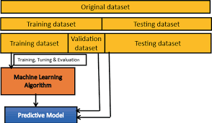
Training Datasets
Purpose: To teach the model.
The AI training dataset is the largest subset and forms the foundation of model development. The model uses this data to identify patterns, relationships, and trends.
Key Characteristics:
- Large size for better learning opportunities
- Diversity to avoid bias and improve generalization
- Well-labeled for supervised learning tasks
Example: AI training datasets with annotated images train models to recognize objects like cars and animals.
Validation Datasets
Purpose: To fine-tune the model.
Validation datasets evaluate the model during training, helping you adjust parameters like learning rates or weights to prevent overfitting.
Key Characteristics:
- Separate from the training data
- Small but representative of the problem space
- Used iteratively to improve performance
Testing Datasets
Purpose: To evaluate the model.
The testing dataset provides an unbiased assessment of the model’s performance on unseen data.
Key Characteristics:
- Exclusively used after training and validation
- Mimics real-world scenarios for robust evaluation
- Should remain untouched during the training process
Example: Testing a sentiment analysis model with user reviews it hasn’t seen before.
How to Split Datasets Effectively
Splitting your machine learning datasets into these three subsets is crucial for accurate model evaluation:
- 70% Training
- 15% Validation
- 15% Testing
*Training data vs Testing data
When we build any machine learning model, the data we use is divided into two important parts: training data and testing data. Training data teaches a model how to make predictions, and testing data checks how well the model has learned.
Training Data
Training data is the dataset used to teach a machine learning model. It usually contains labeled examples (where the correct output is already known). The model studies these examples, finds patterns, and slowly learns to make predictions on its own.
During training, the model
- looks at input and output pairs
- identifies relationships
- adjusts its internal rules
- improves its accuracy over time
Models with large and good-quality training data usually perform better.
Testing Data
Once the model has learned from training data, we need new, unseen data to check if it has learned correctly. This new dataset is called testing data. Testing data helps to:
- measure accuracy
- check if the model is overfitting
- verify if the model can handle new information

Training Data vs Testing Data:

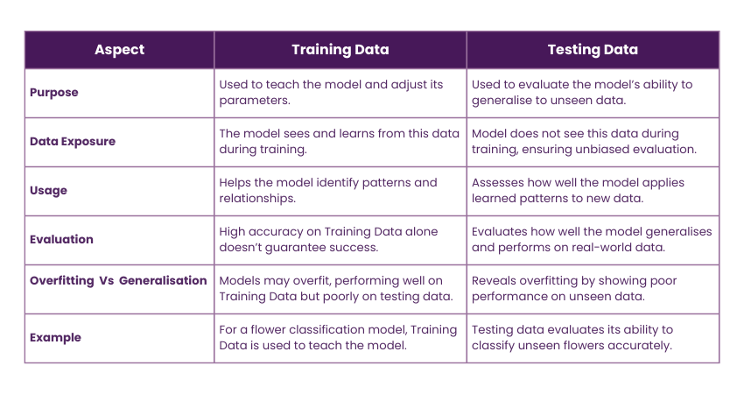
*Types of data in ML:
1. Structured Data
Structured data is highly organized and stored in predefined formats, such as tables, spreadsheets, and relational databases. It follows a fixed schema with clear relationships between data points.
- Examples: Customer records in an SQL database, financial transactions in spreadsheets, or inventory management systems.
- Applications: Used in predictive modeling, fraud detection, and business intelligence.
2. Unstructured Data
Unstructured data lacks a predefined format and does not fit neatly into relational databases. It is typically complex, diverse, and requires advanced preprocessing before use in machine learning models.
- Examples: Images, videos, audio files, emails, and social media posts.
- Applications: Used in computer vision, sentiment analysis, and speech recognition. Deep learning models, such as CNNs (Convolutional Neural Networks) for image processing and NLP models for text processing, are commonly used for unstructured data.
3. Semi-Structured Data
Semi-structured data has some level of organization but does not follow a strict schema like structured data. It contains tags or metadata that help define relationships.
- Examples: JSON and XML files, NoSQL databases like MongoDB, and email metadata.
- Applications: Used in web scraping, log analysis, and document classification.
Different machine learning models handle these data types differently. Structured data benefits from statistical models, while deep learning techniques are better suited for unstructured and semi-structured data.

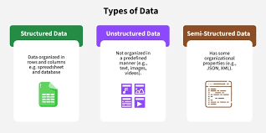
Types of Data Based on Representation
Data in machine learning are broadly categorized into two types − numerical (quantitative) and categorical (qualitative) data. The numerical data can be measured, counted or given a numerical value, for example, age, height, income, etc. The categorical data is non-numeric data that can be arranged in categories with or without meaningful order, for example, gender, blood group, etc.
Further, the numerical data can be categorized into discrete and continuous data. The categorical data can also be categorized into two types − nominal and ordinal.

The data used in machine learning can be broadly categorized into two types −
- Numerical (quantitative) data
- Categorical (qualitative) data
Numerical (Quantitative) Data
The numerical (quantitative) data is data that can be measured, counted or given a numerical value. The examples of numerical data are age, height, income, number of students in class, number of books in a shelf, shoe size, etc.
The numerical data can be categorized into the folloiwng two types −
- Discrete Data
- Continuous Data
1. Discrete Data
The discrete data is numerical data that is countable, finite, and can only take certain values, usually whole numbers. Examples of discrete data are number of students in class, number of books in a shelf, shoe size, number of ducks in a pond, etc.
2. Continuous Data
The continuous data is numerical data that can take any value within a specified range including fractions and decimals. Examples of continuous data are age, height, weight, income, time, temperature, etc.
Categorical (Qualitative) Data
The categorical (qualitative) data can be categorized with or without a meaningful order. For example, gender, blood group, hair color, nationality, the school grades, level of education, range of income, ratings, etc.
The categorical data can be divided into the folloiwng two types −
- Nominal Data
- Ordinal Data
1. Nominal Data
The nominal data is categorical data that can not be arranged in an order or rank. The examples of nominal data are gender, blood group, hair color, nationality, etc.
2. Ordinal Data
The ordinal data is categorical data can be ordered or ranked with a specific attribute. The examples of ordinal data are the school grades, level of education, range of income, ratings, etc
Types of Machine Learning:
Machine Learning (ML) is a subfield of Artificial Intelligence (AI) that focuses on building algorithms and models that enable computers to learn from data and improve with experience without explicit programming for every task. In simple words, Machine Learning teaches systems to learn patterns and make decisions like humans by analyzing and learning from data.
There are several types of machine learning, each with special characteristics and applications. Some of the main types of machine learning algorithms are as follows:
- Supervised Machine Learning
- Unsupervised Machine Learning
- Reinforcement Learning
Additionally, there is a more specific category called Semi-Supervised Learning and Self-Supervised Learning, which combines elements of both supervised and unsupervised learning.
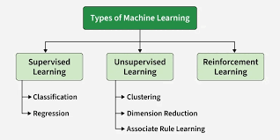
1. Supervised Machine Learning
Supervised learning is defined as when a model gets trained on a "Labeled Dataset". Labelled datasets have both input and output parameters. In Supervised Learning algorithms learn to map points between inputs and correct outputs. It has both training and validation datasets labelled.
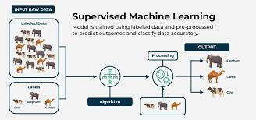
Supervised Learning
Example: If you train a model using labeled images of cats and dogs, it learns the features of each. When shown a new image, it predicts whether it’s a cat or a dog.
There are two main categories of supervised learning that are mentioned below:
1. Classification
Classification predicts categorical outputs, meaning it assigns data into predefined classes like spam/non-spam emails or disease risk categories. These algorithms learn to map input features to discrete labels. Here are some classification algorithms:
- Logistic Regression
- Decision Tree
- Random Forest
- K-Nearest Neighbors (KNN)
- Naive Bayes
- Support Vector Machine
2. Regression
Regression, predicts continuous values, such as house prices or product sales. It learns the relationship between input features and a numerical target variable. Here are some regression algorithms:
- Linear Regression
- Polynomial Regression
- Ridge Regression
- Lasso Regression
- Decision tree
- Random Forest
Where to Use Supervised Learning
- When you have labeled data and want to predict outcomes.
- Ideal for classification (like spam detection) or regression tasks (like price forecasting).
- Best used in domains where historical data with outcomes is already available.
Applications
Supervised learning is used in a wide variety of applications, including:
- Image, speech and text processing: For tasks like image classification, speech recognition and sentiment analysis.
- Predictive analytics: To forecast sales, customer churn, stock prices and weather conditions.
- Recommendation and personalization: Powering systems that suggest products, movies or content.
- Healthcare and finance: Used for medical diagnosis, fraud detection and credit scoring.
- Automation and control: In autonomous vehicles, manufacturing quality checks and gaming AI.
2. Unsupervised Machine Learning
Unsupervised Learning works with unlabeled data, meaning there are no predefined outputs. The algorithm finds hidden patterns, groups or relationships within the data on its own. It’s mainly used for clustering, dimensionality reduction and data visualization.
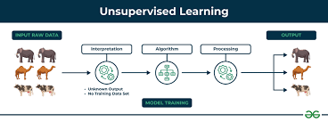
Unsupervised Machine Learning
Example: If you have customer data without labels, the algorithm can group similar customers based on purchase behavior useful for segmentation and marketing.
There are two main categories of unsupervised learning that are mentioned below:
1. Clustering
Clustering is the process of grouping data points into clusters based on their similarity. This technique is useful for identifying patterns and relationships in data without the need for labeled examples. Common techniques include:
- K-Means
- DBSCAN
- Mean-shift
2. Dimensionality Reduction Techniques
Dimensionality reduction helps reduce the number of features while preserving important information. Common techniques include:
- Principal Component Analysis
- Independent Component Analysis
3. Association Rule Learning
Association rule learning is a technique for discovering relationships between items in a dataset. It identifies rules that indicate the presence of one item implies the presence of another item with a specific probability. Common techniques include:
- Apriori
- FP-growth
- Eclat
Where to Use Unsupervised Learning
- When data is unlabeled or unstructured.
- Useful for exploratory analysis, clustering or feature extraction.
- Common in marketing, recommendation systems and fraud detection where patterns matter more than labels.
Applications of Unsupervised Learning
Here are some common applications of unsupervised learning:
- Clustering and segmentation: Group similar data points, customers or images.
- Anomaly detection: Spot unusual patterns or outliers in data.
- Dimensionality reduction: Simplify large datasets while retaining key information.
- Recommendation and marketing: Identify user preferences and improve product suggestions.
- Data preprocessing and analysis: Clean data, detect patterns and support exploratory data analysis (EDA).
difference between supervised and unsupervised learning:
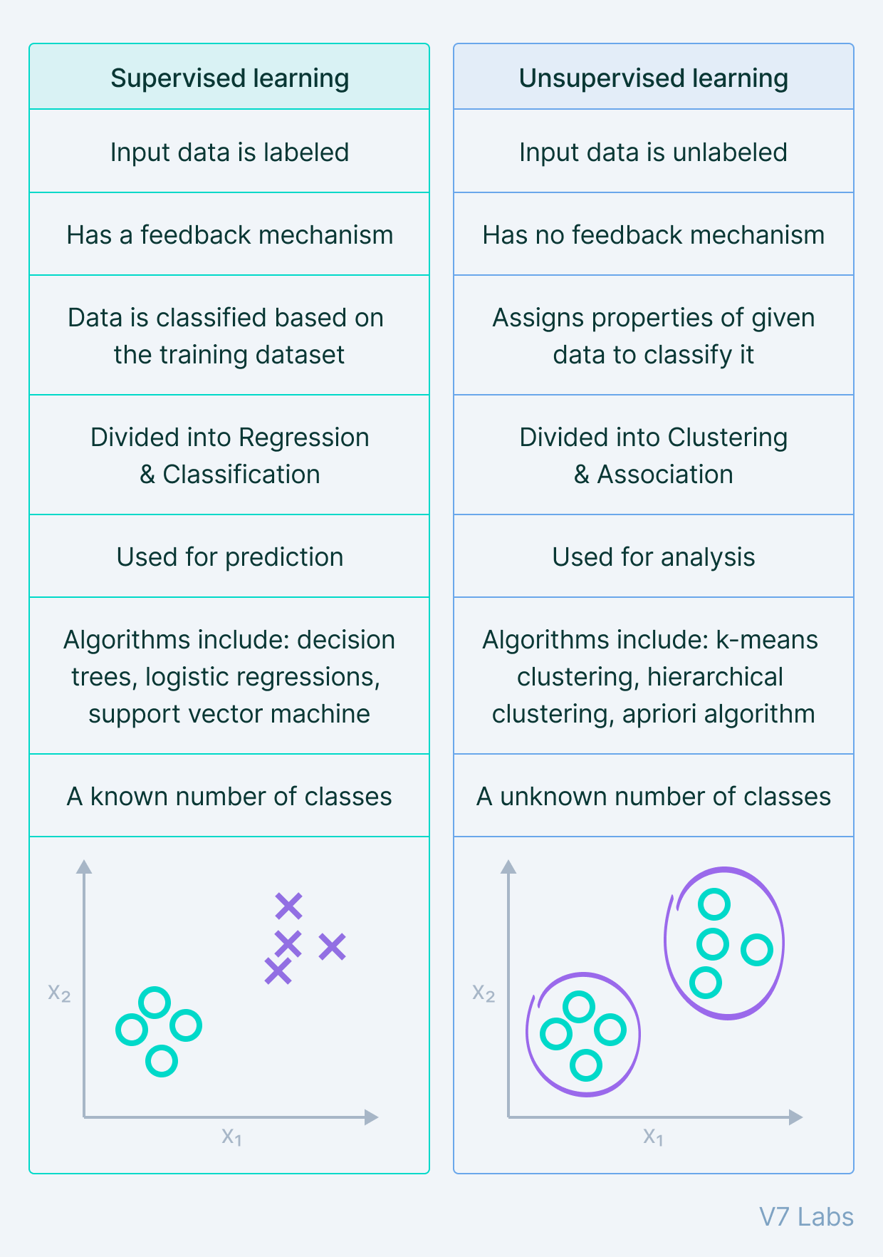
Semi-Supervised Learning in ML: Semi-supervised learning is a hybrid machine learning approach which uses both supervised and unsupervised learning. It uses a small amount of labelled data combined with a large amount of unlabelled data to train models. 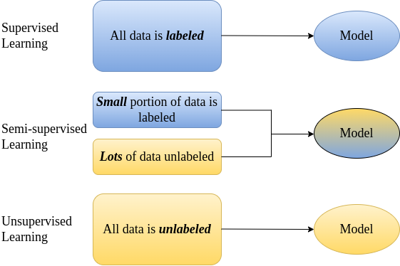
The goal is to learn a function that accurately predicts outputs based on inputs, similar to supervised learning, but with much less labelled data.

When to Use Semi-Supervised Learning
- When labeled data is scarce or costly, such as medical imaging requiring expert annotation.
- When large volumes of unlabeled data exist, like social media or web content.
- For unstructured data types (text, images, audio) where labeling is difficult.
- When classes are rare and labeled examples few, improving class recognition.
- When purely supervised or unsupervised methods are insufficient.
Applications
- Face Recognition: Enhancing accuracy by learning from limited labeled face images plus many unlabeled ones using graph-based methods.
- Handwritten Text Recognition: Adapting models to diverse handwriting styles through generative models.
- Speech Recognition: Improving transcription quality by using unlabeled speech data with CNNs and other techniques.
- Security: Google uses semi-supervised learning for anomaly detection in network traffic and malware detection.
- Finance: PayPal applies it for fraud detection and creditworthiness assessment using transaction data.
Advantages
- Better Generalization: Utilizes both labeled and unlabeled data to capture the whole data structure, improving prediction robustness.
- Cost Efficient: Reduces dependency on costly manual labeling by exploiting unlabeled data.
- Flexible and Robust: Handles different data types and sources, adapting well to changing data distributions.
- Improved Clustering: Refines clusters by leveraging unlabeled data, yielding better class separation.
- Handling Rare Classes: Enhances learning for underrepresented classes where labeled examples are minimal.

Reinforcement Learning:
Reinforcement Learning (RL) is a branch of machine learning that focuses on how agents can learn to make decisions through trial and error to maximize cumulative rewards. RL allows machines to learn by interacting with an environment and receiving feedback based on their actions. This feedback comes in the form of rewards or penalties
Reinforcement Learning revolves around the idea that an agent (the learner or decision-maker) interacts with an environment to achieve a goal. The agent performs actions and receives feedback to optimize its decision-making over time.
- Agent: The decision-maker that performs actions.
- Environment: The world or system in which the agent operates.
- State: The situation or condition the agent is currently in.
- Action: The possible moves or decisions the agent can make.
- Reward: The feedback or result from the environment based on the agent’s action.
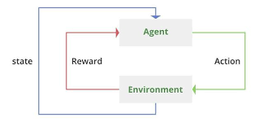
Types of Reinforcements
1. Positive Reinforcement: Positive Reinforcement is defined as when an event, occurs due to a particular behavior, increases the strength and the frequency of the behavior. In other words, it has a positive effect on behavior.
- Advantages: Maximizes performance, helps sustain change over time.
- Disadvantages: Overuse can lead to excess states that may reduce effectiveness.
2. Negative Reinforcement: Negative Reinforcement is defined as strengthening of behavior because a negative condition is stopped or avoided.
- Advantages: Increases behavior frequency, ensures a minimum performance standard.
- Disadvantages: It may only encourage just enough action to avoid penalties.
Online vs. Offline Learning
Reinforcement Learning can be categorized based on how and when the learning agent acquires data from its environment, dividing the methods into online RL and offline RL (also known as batch RL).
Online vs Offline RL
- In online RL, the agent learns by actively interacting with the environment in real-time. It collects fresh data during training by executing actions and observing immediate feedback as it learns.
- Offline RL trains the agent exclusively on a pre-collected static dataset of interactions generated by other agents, human demonstrations or historical logs. The agent does not interact with the environment during learning 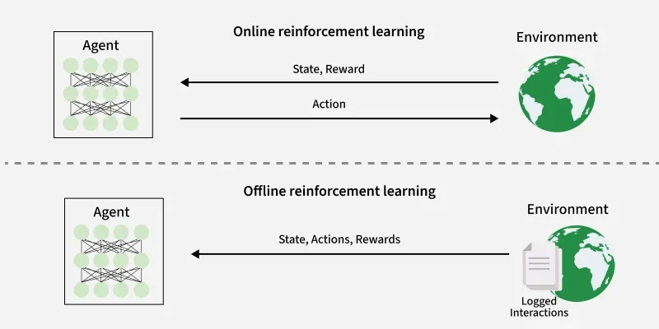.
Application
- Robotics: RL is used to automate tasks in structured environments such as manufacturing, where robots learn to optimize movements and improve efficiency.
- Games: Advanced RL algorithms have been used to develop strategies for complex games like chess, Go and video games, outperforming human players in many instances.
- Industrial Control: RL helps in real-time adjustments and optimization of industrial operations, such as refining processes in the oil and gas industry.
- Personalized Training Systems: RL enables the customization of instructional content based on an individual's learning patterns, improving engagement and effectiveness.
Advantages
- Solves complex sequential decision problems where other approaches fail.
- Learns from real-time interaction, enabling adaptation to changing environments.
- Does not require labeled data, unlike supervised learning.
- Can innovate by discovering new strategies beyond human intuition.
- Handles uncertainty and stochastic environments effectively.
Disadvantages
- Computationally intensive, requiring large amounts of data and processing power.
- Reward function design is critical; poor design leads to unintended behaviors.
- Not suitable for simple problems where traditional methods are more efficient.
- Challenging to debug and interpret, making it hard to explain decisions.
- Exploration-exploitation trade-off requires careful balancing to optimize learning.
Rote learning in machine learning:
Rote learning in Machine Learning is a learning method in which a system memorizes the training data exactly and produces the same output when the same input appears again. The model does not understand patterns or relationships in the data and cannot generalize to new or unseen inputs.
It works like a lookup table, where each input is directly mapped to a stored output. While rote learning is simple and accurate for known data, it requires large memory and fails when new data is introduced.
Features of Rote Learning in AI
- Rote learning in AI learns by memorizing specific examples. For example, Rote learning might memorize a large dataset of text or images without understanding the context.
- Limited Generalization: Rote learning systems struggle to generalize their knowledge to new, unseen situations. They may perform well on tasks similar to what they've memorized but poorly on tasks outside their narrow scope.
- Lack of Adaptability: These systems typically do not adapt well to changes in data or environment because they lack the ability to reason or adapt their knowledge.
- Limited Problem-Solving: Rote learning systems are not effective at problem-solving or making decisions based on the information they've memorized.
Suppose a system is designed to “learn” addition for small numbers:
Input (x, y) | Output (x + y)
(1, 1) | 2
(1, 2) | 3
(2, 2) | 4
- If the input is (1, 2), the system returns 3 (memorized).
- If the input is (3, 4), the system cannot compute the result because it was not in the stored data.
This shows rote learning memorizes specific examples but cannot generalize to unseen inputs.
Advantages of Rote Learning
- Simplicity – Very easy to implement since it only stores input-output pairs.
- Accurate for known data – Produces 100% correct results for memorized inputs.
- No training required – Does not need complex algorithms or learning processes.
- Deterministic behavior – Always gives the same output for the same input.

Disadvantages of Rote Learning
- Cannot generalize – Fails for new or unseen inputs.
- High memory usage – Needs to store every input-output pair.
- Not scalable – Becomes impractical for large datasets.
- No pattern recognition – Cannot learn underlying rules or relationships.
- Limited use in real-world applications – Rarely used in modern Machine Learning systems.

Induction learning in ML:
Inductive learning, also known as inductive reasoning or inductive inference, is a type of learning that involves generalizing from specific instances or examples to make broader generalizations or predictions.
An inductive learning algorithm is a type of machine learning approach where the system learns by observing examples and generalizing patterns from them. The fundamental principle behind inductive learning is to infer a general rule or function from specific instances of input-output pairs. In other words, the algorithm uses training data to derive models that can predict outcomes for new, unseen inputs.
nductive learning algorithms are widely used in applications like spam filtering, medical diagnosis, voice recognition, and recommendation systems. They underpin various models such as decision trees, support vector machines, neural networks, and nearest neighbor classifiers. These systems continuously evolve by learning from labeled datasets and adjusting predictions over time.
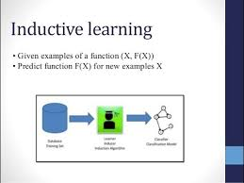
Example
Suppose a system is given the following examples:
Input (Weather) | Output (Play?)
Sunny | Yes
Rainy | No
Sunny | Yes
Overcast | Yes
- From these examples, the system can induce rules like:
  - If Weather = Sunny or Overcast → Play = Yes
  - If Weather = Rainy → Play = No
- Now, if a new input comes (e.g., Weather = Overcast), the system can predict Play = Yes, even though it hasn’t seen this exact input before.
Real-World Examples of Inductive Learning Algorithms
Several widely used machine learning models are based on inductive learning principles:
- Decision Trees: Learn classification or regression rules by splitting data based on feature values, building a tree-like structure from training examples.
- Naive Bayes Classifier: Uses probability and Bayes’ Theorem to predict outcomes based on conditional independence between features.
- Support Vector Machines (SVMs): Find the optimal hyperplane that separates classes in the training data with the maximum margin.
- k-Nearest Neighbors (k-NN): Predicts outcomes by comparing new data points to the most similar labeled examples in the dataset.
*Induction and deduction in machine learning:
Inductive Learning An technique of machine learning called inductive learning trains a model to generate predictions based on examples or observations. During inductive learning, the model picks up knowledge from particular examples or instances and generalizes it such that it can predict outcomes for brand-new data.
When using inductive learning, a rule or method is not explicitly programmed into the model. Instead, the model is trained to spot trends and connections in the input data and then utilize this knowledge to predict outcomes from fresh data.
In supervised learning situations, where the model is trained using labeled data, inductive learning is frequently utilized. A series of samples with the proper output labels are used to train the model.
Deductive Learning
Deductive learning is a method of machine learning in which a model is built using a series of logical principles and steps. In deductive learning, the model is specifically designed to adhere to a set of guidelines and processes in order to produce predictions based on brand-new, unexplored data.
In rule-based systems, expert systems, and knowledge-based systems, where the rules and processes are clearly set by domain experts, deductive learning is frequently utilized. The model is trained to adhere to the guidelines and processes in order to derive judgments or predictions from the input data.
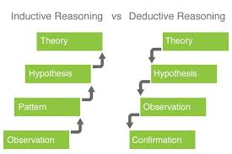
Examples of Inductive Learning Algorithms
- Decision Trees
- Neural Networks
- K-Nearest Neighbors (KNN)
Advantages of Inductive Learning
- Data: Handles complex data.
- Pattern Recognition: Identifies hidden patterns and relationships in data easily.
Disadvantages of Inductive Learning
- Overfitting: Inductive learning may overfit the training data. This can lead to poor generalization of new data.
Examples of Deductive Learning Algorithms
- Rule-based systems: Uses a set of predefined rules to make decisions.
- Expert systems: Applies domain-specific knowledge to solve problems.
Advantages of Deductive Learning
- Transparency: The reasoning process is transparent
Disadvantages of Deductive Learning
- Less flexible: Less flexible in handling new or unseen data that doesn’t fit the predefined rules.


*Matching in Machine Learning
Matching in machine learning refers to the process of comparing new input data with existing or stored data in order to find similarities, patterns, or exact matches. It is a fundamental concept used in many learning systems, especially those that rely on examples rather than explicit rules.
Types of Matching in Machine Learning
1. Exact Matching
In exact matching, the input data must exactly match the stored data. Even a small difference will cause the match to fail. This type of matching is simple and fast but very rigid.
Examples:
• Password checking
• Lookup tables
• Rote learning systems

2. Partial or Approximate Matching
In partial matching, the system allows some differences between the input data and stored data. A match is accepted if the similarity is above a certain threshold. This method is more flexible and commonly used in real-world applications.
Examples:
• Face recognition
• Speech recognition
• Recommendation systems

* Feature Engineering: Feature Engineering is the process of selecting, creating or modifying features like input variables or data to help machine learning models learn patterns more effectively. It involves transforming raw data into meaningful inputs that improve model accuracy and performance
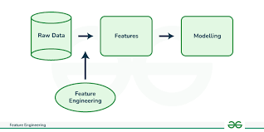
Processes Involved in Feature Engineering

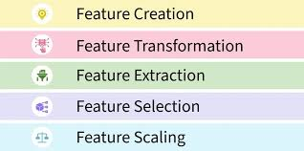
Feature Creation: Feature creation involves generating new features from domain knowledge or by observing patterns in the data. It can be:
- Domain-specific: Created based on industry knowledge like business rules.
- Data-driven: Derived by recognizing patterns in data.
- Synthetic: Formed by combining existing features.
2. Feature Transformation: Transformation adjusts features to improve model learning:
- Normalization & Scaling: Adjust the range of features for consistency.
- Encoding: Converts categorical data to numerical form i.e one-hot encoding.
- Mathematical transformations: Like logarithmic transformations for skewed data.
3. Feature Extraction: Extracting meaningful features can reduce dimensionality and improve model accuracy:
- Dimensionality reduction: Techniques like PCA reduce features while preserving important information.
- Aggregation & Combination: Summing or averaging features to simplify the model.
4. Feature Selection: Feature selection involves choosing a subset of relevant features to use:
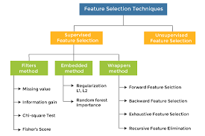
- Filter methods: Based on statistical measures like correlation.
- Wrapper methods: Select based on model performance.
- Embedded methods: Feature selection integrated within model training.
5. Feature Scaling: Scaling ensures that all features contribute equally to the model:
- Min-Max scaling: Rescales values to a fixed range like 0 to 1.
- Standard scaling: Normalizes to have a mean of 0 and variance of 1.
Steps in Feature Engineering
Feature engineering can vary depending on the specific problem but the general steps are:
- Data Cleaning: Identify and correct errors or inconsistencies in the dataset to ensure data quality and reliability.
- Data Transformation: Transform raw data into a format suitable for modeling including scaling, normalization and encoding.
- Feature Extraction: Create new features by combining or deriving information from existing ones to provide more meaningful input to the model.
- Feature Selection: Choose the most relevant features for the model using techniques like correlation analysis, mutual information and stepwise regression.
- Feature Iteration: Continuously refine features based on model performance by adding, removing or modifying features for improvement.
*stages of machine learning:
Machine Learning Lifecycle is a structured process that defines how machine learning (ML) models are developed, deployed and maintained. It consists of a series of steps that ensure the model is accurate, reliable and scalable.
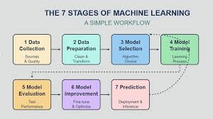
1.Data Collection
- Description: Gather raw data from various sources such as sensors, databases, online repositories, or user inputs.
- Importance: The quality and quantity of data directly affect the ML model’s performance.
- Example: Collecting historical sales data for demand forecasting.

2. Data Preprocessing
- Description: Prepare the data for analysis by cleaning, transforming, and organizing it.
- Key Steps:
  - Handling missing values
  - Removing duplicates and errors
  - Normalization or scaling
  - Encoding categorical variables
- Example: Converting “Yes/No” responses into 1/0 for ML models.

3. Model Selection / Learning Algorithm
- Description: Choose an appropriate machine learning algorithm based on the problem type.
- Types:
  - Supervised Learning (Regression, Classification)
  - Unsupervised Learning (Clustering, Dimensionality Reduction)
  - Reinforcement Learning
- Example: Using Decision Trees for classification or Linear Regression for predicting prices.

4. Training the Model
- Description: Feed the cleaned and processed data into the chosen algorithm to learn patterns and relationships.
- Key Concepts:
  - Training dataset
  - Feature selection
  - Learning parameters
- Example: Training a model to predict student grades based on attendance and assignment scores.

5. Evaluation / Testing
- Description: Test the trained model on new, unseen data to check its performance.
- Metrics:
  - Accuracy, Precision, Recall, F1 Score (for classification)
  - Mean Squared Error (for regression)
- Example: Checking if the trained spam filter correctly classifies new emails.

6. Deployment
- Description: Implement the trained model in real-world applications to make predictions or decisions automatically.
- Example: A recommendation system on Netflix suggesting movies to users.

7. Monitoring and Maintenance
- Description: Continuously monitor the model’s performance and update it if the data or environment changes.
- Importance: Prevents model degradation over time.
- Example: Updating a fraud detection model as new types of fraud emerge.
Search and learning in Machine Learning
Search = systematically exploring possibilities to find a good solution.
Where search shows up
- State-space search
Used in classic AI problems like:
  - Pathfinding (A*, BFS, DFS)
  - Games (chess, Go, minimax, alpha-beta pruning)
- Optimization
  - Finding parameters that minimize loss
  - Hyperparameter tuning (grid search, random search)
- Planning & reasoning
  - Robotics
  - Automated planning systems
Key ideas
- Search space (all possible solutions)
- Cost / objective function
- Heuristics (rules of thumb to search faster)
- Trade-off: optimality vs efficiency
Example:
Finding the shortest path from A to B on a map using A* search.

Learning in Machine Learning
Learning = improving performance using data and experience.
Instead of trying all possibilities, the system:
“Looks at data → finds patterns → generalizes to new cases.”
Types of learning
- Supervised learning
  - Labeled data
  - Regression, classification
- Unsupervised learning
  - No labels
  - Clustering, dimensionality reduction
- Reinforcement learning
  - Learn by trial and error
  - Rewards & penalties
Key ideas
- Training data
- Model parameters
- Loss function
- Generalization
Example:
Training a neural network to recognize cats from labeled images.

