UNIT-1

1.1 Introduction to Software Engineering
The term software engineering is the product of two words, software, and engineering.
The software is a collection of integrated programs.
Software subsists of carefully-organized instructions and code written by developers on any of various particular computer languages.
Computer programs and related documentation such as requirements, design models and user manuals.
Software=Program+documentation+licensing.
Engineering is the application of scientific and practical knowledge to invent, design, build, maintain, and improve frameworks, processes, etc.

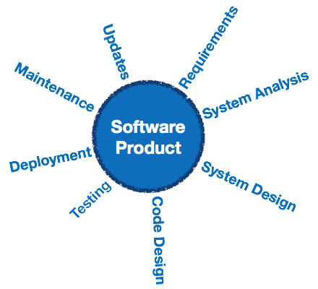
Software Engineering is an engineering branch related to the evolution of software product using well-defined scientific principles, techniques, and procedures. The result of software engineering is an effective and reliable software product.

Software Evolution:
- Software evolution is the process of developing and updating a software for different reasons.
- In software development lifecycle, there are many phases/stages where new requirements are emerged and implemented so organizations prefers changing and evolving in the software rather than making a new software product.
- Software Evolution refers to :
- changing in software
- maintaining the software
What are the factors where changes are needed in the software ?
- For changing the business environment.
- New requirements are proposed during SDLC.
- For debugging.
- To change the procedures.
- In adding new resources and computer systems.
- To increase the performance of the software product.
How to maintain a software ?
- The software maintenance is done for increasing the system performance.
- To detect and correct the bugs present in the software product.
- Update and change in the software
Types of software maintenance:
- Corrective Maintenance :: To correct any type of error present in the software product, the corrective maintenance is used.
- Adaptive Maintenance :: As new technology emerges, the software is updated by taking up the adaptive maintenance.
- Perfective Maintenance :: The object of perfective maintenance is to improve software reliability and performance and adding some new things in software product.
- Preventive Maintenance :: There is need of updation to prevention or correction of future errors of the software.

Difference between Product and Process
Product: In the context of software engineering, Product includes any software manufactured based on the customer’s request. This can be a problem solving software or computer based system. It can also be said that this is the result of a project.
Process: Process is a set of sequence steps that have to be followed to create a project. The main purpose of a process is to improve the quality of the project. The process serves as a template that can be used through the creation of its examples and is used to direct the project.

SOFTWARE PARADIGM:

- Software paradigms refer to the methods and steps, which are taken while designing the software.
- Programming paradigm is a subset of software design paradigm which is further a subset of software development paradigm.
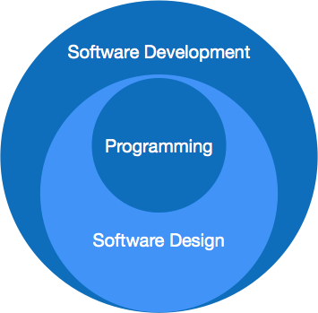
- 1.Software development paradigm
Requirement gathering, software design, programming
- 2. software design paradigm
Design, maintenance, programming.
- 3.Programming paradigm
Coding, Testing, Integration

PROGRAM VS SOFTWARE PRODUCT:
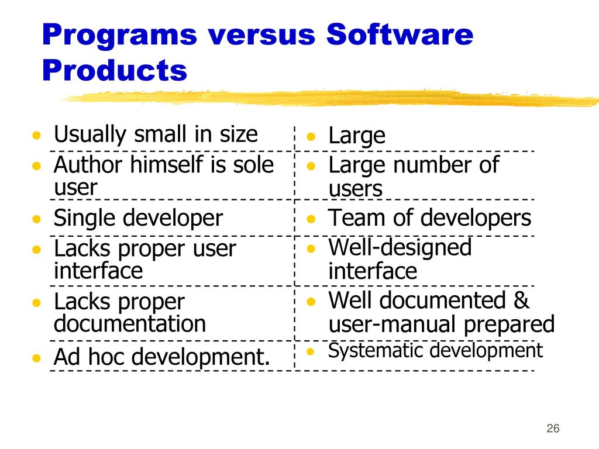

Challenges of Software Engineering:
Here are some critical challenges faced by software engineers:
- In safety-critical areas such as space,nuclear power plants, etc. the cost of software failure can be massive because lives are at risk.
- Increased market demands for fast turnaround time.
- Dealing with the increased complexity of software need for new applications.
- The diversity of software systems should be communicating with each other.
Characteristics of Good Software
Any software should be judged by what it offers and what are the methods which help you to use it.
Every software must satisfy the following attributes:
- Operational
- Transitional
- Maintenance
Here are some important characteristics of good software developed by software professionals
Operational
This characteristic let us know about how well software works in the operations which can be measured on:
- Budget
- Efficiency
- Usability
- Dependability
- Correctness
- Functionality
- Safety
- Security
Transitional
This is an essential aspect when the software is moved from one platform to another:
- Interoperability
- Reusability
- Portability
- Adaptability
Maintenance
This aspect talks about how well software has the capabilities to adapt itself in the quickly changing environment:
- Flexibility
- Maintainability
- Modularity
- Scalability

How to Become A Software Engineer?
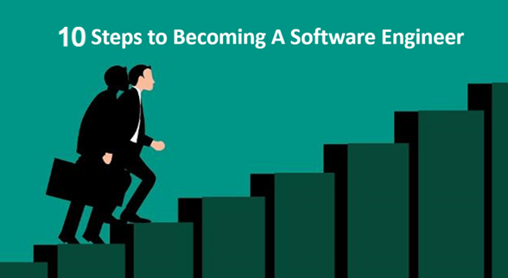
Software engineering is an ever-changing profession. Therefore, one should adopt as new technologies are developed. As it has shifting nature, there are many different entry points into the IT profession.
However, there is no single way of achieving this. Here are some steps to becoming a professional software engineer.
Top 10 Behavioral Interview Questions and Answers

Step #1: Be Clear About Your End Goal
Starting a new career is not easy. However, when you have a final destination in mind, it helps when you find and deal with a hurdle in your road. You should have a clear goal like:
- I want to build my career as a software engineer
- I want to work as a software engineer at an established IT company.
- I want to work as a team member and get paid well for it.

Step #2: Select A Language to Learn
Software engineering never focuses exclusively on coding. However, you should know at least a couple of languages, and a deeper understanding of how they will function. There is no common agreement on which languages are most useful.
Below are given the list of some popular programming languages:
- Python
- JavaScript
- C#
- C++
- Ruby
- Java

Step #3: Earn A Degree in Computer Science or A Related Field
You should first earn a degree in computer science or a related field. You should have at least a bachelor’s degree to begin your career as a software engineer.
Majoring in computer science will offer you the most useful background for designing software. Interviewers will ask questions regarding data structures and algorithms. Therefore, the theoretical knowledge provided by traditional computer science degrees best prepares you for this.
However, you will mostly spend your time outside of the classroom coding software and to learn how to write real software.

Step #4: Supplement your studies
Educational books are frequently outdated. Reference books are revised much slower than software is updated. All the education institutes provide theoretical concepts and ways of thinking that can be important for your success.
Although, how much you will get paid is being able to apply the knowledge of the real-world software. This is where your study helps you.
Here are some ways to supplement your learning:
- StackOverflow is the most reliable question and answer website for developers. You can search according to the technology, problem space, or language you want to improve in.
- Sites like CodinGame and CodeWars offer thousands of programming solutions which help you to test your skills.

Step #5: Read Code Written by Experienced Developers
Another useful aspect of becoming a software engineer is learning how to read other people’s code. You can do this easily by visiting sites like GitHub repositories and looking through documentation.
However, sometimes documentation also goes wrong, but most of the source code accurate in these sites. Therefore, by learning to read that code, you’ll be able to understand how a specific program is working.

Step #6: Find A Community of Software Engineers
You need to find a community to learn which guide you to success as a software engineer. Therefore, when you are surrounded by a community of like-minded people, you have an automatic support system. A real-world software engineering community gives you guidance on where to focus your learning. Sites like Meetup is an ideal choice to find other professionals.

Step #7: Build Projects
Nothing like practical experience. You need to start building projects on a language you are comfortable with. By doing this, you not only enhance your learning but also found a potential employer. As you learn how to code, build projects, etc., you should slowly help you to build up your professional network.

Step #8: Master Your Pre-Interview Skills
Next, you need to focus on your resume as it plays a vital part for your hiring. You’ll need to master three things: resume, cover letter, and your online presence.
Hiring HR managers still look at them to get a snapshot of your skills and experience. Moreover, cover letters are needed when applying for jobs online; they’re your opportunity to get someone’s attention and make an impression.

Step #9: Ace Your Job Interview
Finally, the time is come to face the interview. Most of IT companies start with a screening interview, usually done on the internet, at home. After that, you need to face a phone interview. If you successfully clear both interviews, you’ll land the on-site interview.

Step #10: Accept the Job Offer
After you successfully clear round of interviews and demonstrate your new skills, you will likely to get a job offer. Select the best which helps you to enhance your career.

What Does A Software Engineer Do?
Here, are important roles played by software engineer:
- He or she should be a good programmer and should be well-versed in data structures and algorithms.
- Should be fluent in more than one programming language.
- Should be familiar with various design approaches.
- Responsible for defining the feasibility of software operations through problem definition, evaluation, analysis, and solution development.
- Documenting and demonstrating solutions by developing flowcharts, diagrams, documentation, diagrams, layouts, code comments, etc.
- Developing solutions by following software development standards.
- Improves operations by completing systems analysis work and make a recommendation for inefficient procedures and policies.
- Obtaining and licensing software after gaining relevant data from vendors.
- Testing and approving products
- Providing relevant data through the collection, analysis, and summarizing of service and development issues

Best practices for Software Engineers
Here are some best practices for software engineers:
- Software engineers should act in such a way that it is beneficial to the client as well as the employer.
- Ensure software products and related modifications which should meet the highest professional standards.
- Promote an ethical approach for software development and maintenance.
NEED OF SOFTWARE ENGINEERING
- The need of software engineering arises because of higher rate of change in user requirements and environment on which the software is working.
  - Large software – it is easier to build a wall than to a house or building, likewise, as the size of software become large engineering has to step to give it a scientific process.
  - Scalability- if the software process were not based on scientific and engineering concepts, it would be easier to re-create new software than to scale an existing one.
  - Cost- as hardware industry has shown its skills and huge manufacturing has lower down the price of computer and electronic hardware. But the cost of software remains high if proper process is not adapted.
  - Dynamic nature:- the always growing and adapting nature of software hugely depends upon the environment in which user works. If the nature of software is always changing, new enhancements need to be done in the existing one. This is where software engineering plays a good role.
Quality management- better process of software development provides better and quality software product.
SOFTWARE ENGINEERING - A LAYERED TECHNOLOGY:
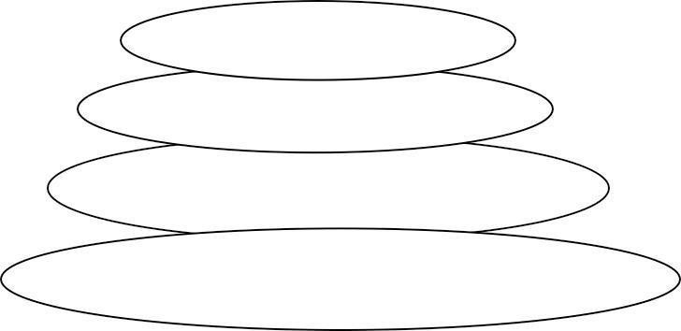
Tools

Methods

Process
A quality focus
Software Engineering Layers

Software engineering is a layered technology. Any engineering approach must rest on an organizational commitment to quality. The bedrock that supports software engineering is a quality focus.

The foundation for software engineering is the process layer. Software engineering process is the glue that holds the technology layers. Process defines a framework that must be established for effective delivery of software engineering technology.

The software forms the basis for management control of software projects and establishes the context
in which
- technical methods are applied,
- work products are produced,
- milestones are established,
- quality is ensured,
- And change is properly managed.

Software engineering methods rely on a set of basic principles that govern area of the technologyand include modeling activities.

Methods encompass a broad array of tasks that include communication,requirements analysis, design modeling, program construction, Testing and support.

Software engineering tools provide automated or semi automated support for the process and the methods. When tools are integrated so that information created by one tool can be used by another, a system for the support of software development, called computer-aided software engineering, is established.

"A process defines who is doing what, when, and how to reach a certain goal."

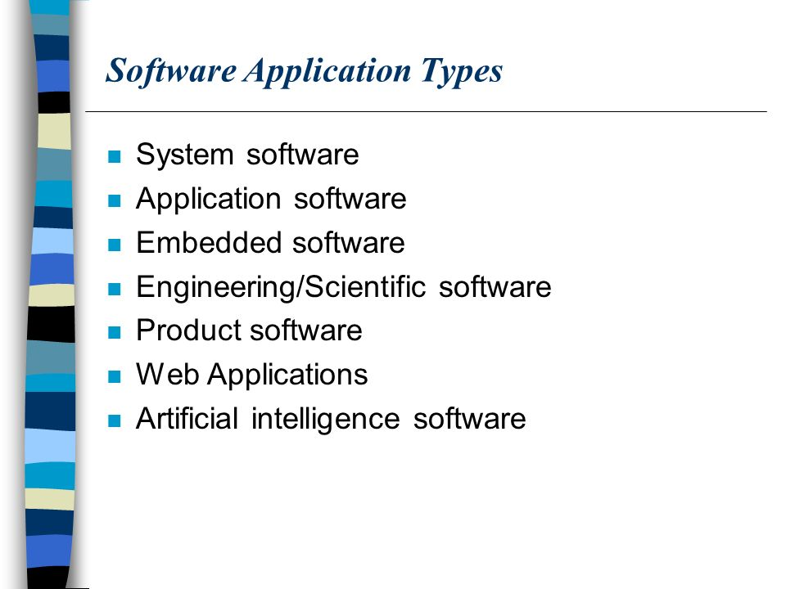

1.2

BASICS OF SOFTWARE DEVELOPMENT LIFE CYCLE AND ITS PHASES
LIFE CYCLE MODEL
- A software life cycle model (also called process model) is a descriptive and diagrammatic representation of the software life cycle. A life cycle model represents all the activities required to make a software product transit through its life cycle phases. It also captures the order in which these activities are to be undertaken. In other words, a life cycle model maps the different activities performed on a software product from its inception to retirement. Different life cycle models may map the basic development activities to phases in different ways. Thus, no matter which life cycle model is followed, the basic activities are included in all life cycle models though the activities may be carried out in different orders in different life cycle models. During any life cycle phase, more than one activity may also be carried out. For example, the design phase might consist of the structured analysis activity followed by the structured design activity.
THE NEED FOR A SOFTWARE LIFE CYCLE MODEL
- The development team must identify a suitable life cycle model for the particular project and then adhere to it. Without using of a particular life cycle model the development of a software product would not be in a systematic and disciplined manner. When a software product is being developed by a team there must be a clear understanding among team members about when and what to do. Otherwise it would lead to chaos and project failure. This problem can be illustrated by using an example. Suppose a software development problem is divided into several parts and the parts are assigned to the team members. From then on, suppose the team members are allowed the freedom to develop the parts assigned to them in whatever way they like. It is possible that one member might start writing the code for his part, another might decide to prepare the test documents first, and some other engineer might begin with the design phase of the parts assigned to him. This would be one of the perfect recipes for project failure.
SDLC ACTIVITIES
- SDLC provides a series of steps to be followed to design and develop a software product efficiently. SDLC framework includes the following steps:
COMMUNICATION
- This is the first step where the user initiates the request for a desired software product. He contacts the service provider and tries to negotiate the terms. He submits his request to the service providing organization in writing.
REQUIREMENT GATHERING
- This step onwards the software development team works to carry on the project. The team holds discussions with various stakeholders from problem domain and tries to bring out as much information as possible on their requirements. The requirements are contemplated and segregated into user requirements, system requirements and functional requirements. The requirements are collected using a number of practices as given - studying the existing or obsolete system and software, conducting interviews of users and developers, referring to the database or collecting answers from the questionnaires.
FEASIBILITY STUDY
- After requirement gathering, the team comes up with a rough plan of software process. At this step the team analyzes if a software can be made to fulfill all requirements of the user and if there is any possibility of software being no more useful. It is found out, if the project is financially, practically and technologically feasible for the organization to take up. There are many algorithms available, which help the developers to conclude the feasibility of a software project.
SYSTEM ANALYSIS
- At this step the developers decide a roadmap of their plan and try to bring up the best software model suitable for the project. System analysis includes Understanding of software product limitations, learning system related problems or changes to be done in existing systems beforehand, identifying and addressing the impact of project on organization and personnel etc. The project team analyzes the scope of the project and plans the schedule and resources accordingly.

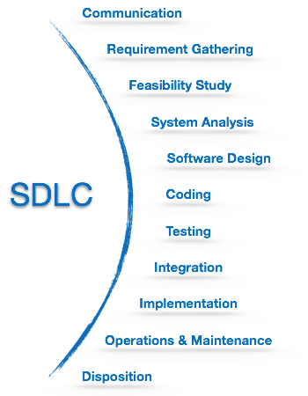
SOFTWARE DESIGN
- Next step is to bring down whole knowledge of requirements and analysis on the desk and design the software product. The inputs from users and information gathered in requirement gathering phase are the inputs of this step. The output of this step comes in the form of two designs; logical design and physical design. Engineers produce meta-data and data dictionaries, logical diagrams, data-flow diagrams and in some cases pseudo codes.
CODING
- This step is also known as programming phase. The implementation of software design starts in terms of writing program code in the suitable programming language and developing error-free executable programs efficiently.
TESTING
- An estimate says that 50% of whole software development process should be tested. Errors may ruin the software from critical level to its own removal. Software testing is done while coding by the developers and thorough testing is conducted by testing experts at various levels of code such as module testing, program testing, product testing, in-house testing and testing the product at user’s end. Early discovery of errors and their remedy is the key to reliable software.
INTEGRATION
- Software may need to be integrated with the libraries, databases and other program(s). This stage of SDLC is involved in the integration of software with outer world entities.
IMPLEMENTATION
- This means installing the software on user machines. At times, software needs post-installation configurations at user end. Software is tested for portability and adaptability and integration related issues are solved during implementation.
OPERATION AND MAINTENANCE
- This phase confirms the software operation in terms of more efficiency and less errors. If required, the users are trained on, or aided with the documentation on how to operate the software and how to keep the software operational. The software is maintained timely by updating the code according to the changes taking place in user end environment or technology. This phase may face challenges from hidden bugs and real-world unidentified problems.
DISPOSITION
- As time elapses, the software may decline on the performance front. It may go completely obsolete or may need intense up gradation. Hence a pressing need to eliminate a major portion of the system arises. This phase includes archiving data and required software components, closing down the system, planning disposition activity and terminating system at appropriate end-of-system time.

DIFFERENT SOFTWARE LIFE CYCLE MODELS
- There are various software development life cycle models defined and designed which are followed during the software development process. These models are also referred as software development process models. Each process model follows a series of steps unique to its type to ensure success in the process of software development.
- Classical Waterfall Model
- Iterative Model
- Incremental Model
- Prototyping Model
- RAD Model
- Spiral Model
- V- Model
- Other related methodologies are agile model, rad model, rapid application development and prototyping models.
  - WATERFALL MODEL
:
DIFFERENT PHASES OF THE CLASSICAL WATERFALL MODEL:
- Water fall model was the first process model to be introduced. It is also referred to as a linear-sequential life cycle model. It is very simple to understand and use. In a waterfall model, each phase must be completed before the next phase can begin and there is no overlapping in the phases.
- The waterfall model is the earliest SDLC approach that was used for software development.
- The waterfall model illustrates the software development process in a linear sequential flow. This mean that any phase in the development process begins only if the previous phase is complete. In this waterfall model, the phases do not overlap.

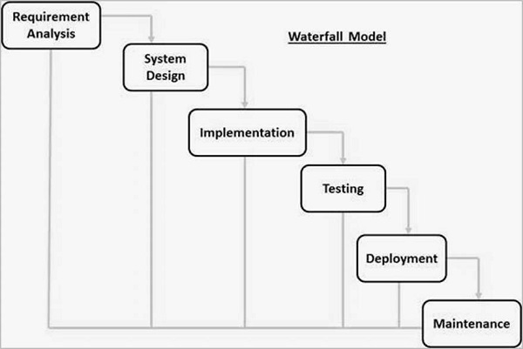
  - Requirement Gathering and analysis − All possible requirements of the system to be developed are captured in this phase and documented in a requirement specification document.
  - System Design − The requirement specifications from first phase are studied in this phase and the system design is prepared. This system design helps in specifying hardware and system requirements and helps in defining the overall system architecture.
  - Implementation − With inputs from the system design, the system is first developed in small programs called units, which are integrated in the next phase. Each unit is developed and tested for its functionality, which is referred to as Unit Testing.
  - Integration and Testing − All the units developed in the implementation phase are integrated into a system after testing of each unit. Post integration the entire system is tested for any faults and failures.
  - Deployment of system − Once the functional and non-functional testing is done; the product is deployed in the customer environment or released into the market.
  - Maintenance − There are some issues which come up in the client environment. To fix those issues, patches are released. Also to enhance the product some better versions are released. Maintenance is done to deliver these changes in the customer environment.
WATERFALL MODEL - APPLICATION
- Every software developed is different and requires a suitable SDLC approach to be followed based on the internal and external factors. Some situations where the use of Waterfall model is most appropriate are −
  - Requirements are very well documented, clear and fixed.
  - Product definition is stable.
  - Technology is understood and is not dynamic.
  - There are no ambiguous requirements.
  - Ample resources with required expertise are available to support the product.
  - The project is short.
SOME OF THE MAJOR ADVANTAGES OF THE WATERFALL MODEL
  - Simple and easy to understand and use
  - Easy to manage due to the rigidity of the model. Each phase has specific deliverables and a review process.
  - Phases are processed and completed one at a time.
  - Works well for smaller projects where requirements are very well understood.
  - Clearly defined stages.
  - Well understood milestones.
  - Easy to arrange tasks.
  - Process and results are well documented.
WATERFALL MODEL - DISADVANTAGES
- The disadvantage of waterfall development is that it does not allow much reflection or revision. Once an application is in the testing stage, it is very difficult to go back and change something that was not well-documented or thought upon in the concept stage.
The major disadvantages of the Waterfall Model are as follows −
  - No working software is produced until late during the life cycle.
  - High amounts of risk and uncertainty.
  - Not a good model for complex and object-oriented projects.
  - Poor model for long and ongoing projects.
  - Not suitable for the projects where requirements are at a moderate to high risk of changing. So, risk and uncertainty is high with this process model.
  - It is difficult to measure progress within stages.
  - Cannot accommodate changing requirements.
  - Adjusting scope during the life cycle can end a project.
  - Integration is done as a "big-bang. at the very end, which doesn't allow identifying any technological or business bottleneck or challenges early.

Iterative Model
In this Model, you can start with some of the software specifications and develop the first version of the software. After the first version if there is a need to change the software, then a new version of the software is created with a new iteration. Every release of the Iterative Model finishes in an exact and fixed period that is called iteration.
The Iterative Model allows the accessing earlier phases, in which the variations made respectively. The final output of the project renewed at the end of the Software Development Life Cycle (SDLC) process.
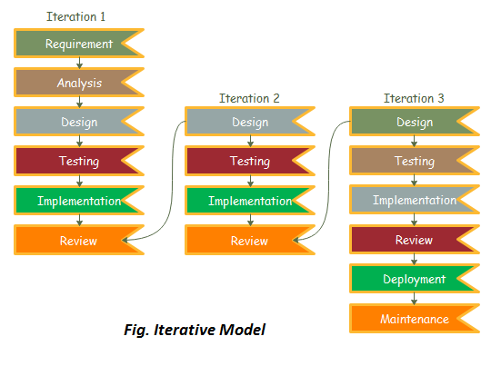

The various phases of Iterative model are as follows:
1. Requirement gathering & analysis: In this phase, requirements are gathered from customers and check by an analyst whether requirements will fulfil or not. Analyst checks that need will achieve within budget or not. After all of this, the software team skips to the next phase.
2. Design: In the design phase, team design the software by the different diagrams like Data Flow diagram, activity diagram, class diagram, state transition diagram, etc.
3. Implementation: In the implementation, requirements are written in the coding language and transformed into computer programmes which are called Software.
4. Testing: After completing the coding phase, software testing starts using different test methods. There are many test methods, but the most common are white box, black box, and grey box test methods.
5. Deployment: After completing all the phases, software is deployed to its work environment.
6. Review: In this phase, after the product deployment, review phase is performed to check the behaviour and validity of the developed product. And if there are any error found then the process starts again from the requirement gathering.
7. Maintenance: In the maintenance phase, after deployment of the software in the working environment there may be some bugs, some errors or new updates are required. Maintenance involves debugging and new addition options.

When to use the Iterative Model?
- When requirements are defined clearly and easy to understand.
- When the software application is large.
- When there is a requirement of changes in future.

Advantage(Pros) of Iterative Model:
- Testing and debugging during smaller iteration is easy.
- A Parallel development can plan.
- It is easily acceptable to ever-changing needs of the project.
- Risks are identified and resolved during iteration.
- Limited time spent on documentation and extra time on designing.

Disadvantage(Cons) of Iterative Model:
- It is not suitable for smaller projects.
- More Resources may be required.
- Design can be changed again and again because of imperfect requirements.
- Requirement changes can cause over budget.
- Project completion date not confirmed because of changing requirements.

3.Incremental Model
Incremental Model is a process of software development where requirements divided into multiple standalone modules of the software development cycle. In this model, each module goes through the requirements, design, implementation and testing phases. Every subsequent release of the module adds function to the previous release. The process continues until the complete system achieved.
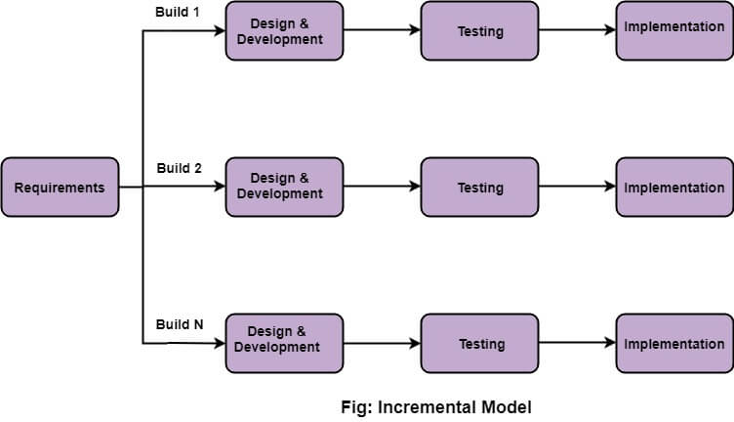

The various phases of incremental model are as follows:
1. Requirement analysis: In the first phase of the incremental model, the product analysis expertise identifies the requirements. And the system functional requirements are understood by the requirement analysis team. To develop the software under the incremental model, this phase performs a crucial role.
2. Design & Development: In this phase of the Incremental model of SDLC, the design of the system functionality and the development method are finished with success. When software develops new practicality, the incremental model uses style and development phase.
3. Testing: In the incremental model, the testing phase checks the performance of each existing function as well as additional functionality. In the testing phase, the various methods are used to test the behavior of each task.
4. Implementation: Implementation phase enables the coding phase of the development system. It involves the final coding that design in the designing and development phase and tests the functionality in the testing phase. After completion of this phase, the number of the product working is enhanced and upgraded up to the final system product

When we use the Incremental Model?
- When the requirements are superior.
- A project has a lengthy development schedule.
- When Software team are not very well skilled or trained.
- When the customer demands a quick release of the product.
- You can develop prioritized requirements first.

Advantage of Incremental Model
- Errors are easy to be recognized.
- Easier to test and debug
- More flexible.
- Simple to manage risk because it handled during its iteration.
- The Client gets important functionality early.

Disadvantage of Incremental Model
- Need for good planning
- Total Cost is high.
- Well defined module interfaces are needed.

4.Prototype Model
The prototype model requires that before carrying out the development of actual software, a working prototype of the system should be built. A prototype is a toy implementation of the system. A prototype usually turns out to be a very crude version of the actual system, possible exhibiting limited functional capabilities, low reliability, and inefficient performance as compared to actual software. In many instances, the client only has a general view of what is expected from the software product. In such a scenario where there is an absence of detailed information regarding the input to the system, the processing needs, and the output requirement, the prototyping model may be employed.
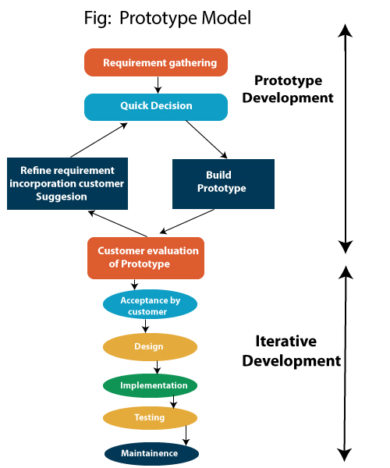

Steps of Prototype Model
- Requirement Gathering and Analyst
- Quick Decision
- Build a Prototype
- Assessment or User Evaluation
- Prototype Refinement
- Engineer Product

Advantage of Prototype Model
- Reduce the risk of incorrect user requirement
- Good where requirement are changing/uncommitted
- Regular visible process aids management
- Support early product marketing
- Reduce Maintenance cost.
- Errors can be detected much earlier as the system is made side by side.

Disadvantage of Prototype Model
- An unstable/badly implemented prototype often becomes the final product.
- Require extensive customer collaboration
  - Costs customer money
  - Needs committed customer
  - Difficult to finish if customer withdraw
  - May be too customer specific, no broad market
- Difficult to know how long the project will last.
- Easy to fall back into the code and fix without proper requirement analysis, design, customer evaluation, and feedback.
- Prototyping tools are expensive.
- Special tools & techniques are required to build a prototype.
- It is a time-consuming process.
5.RAD Model :
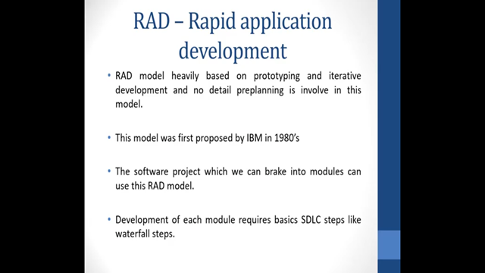

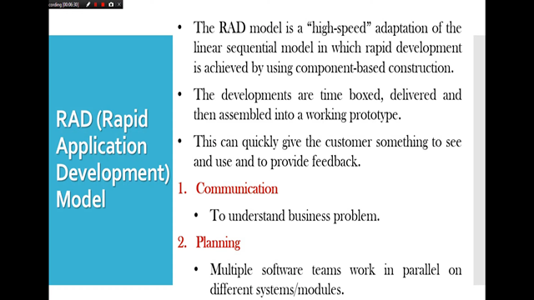
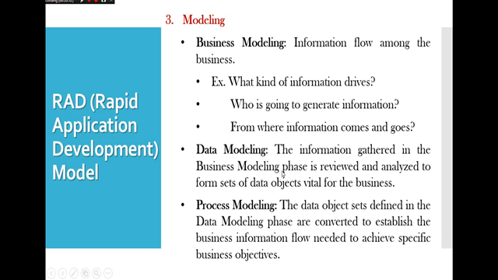
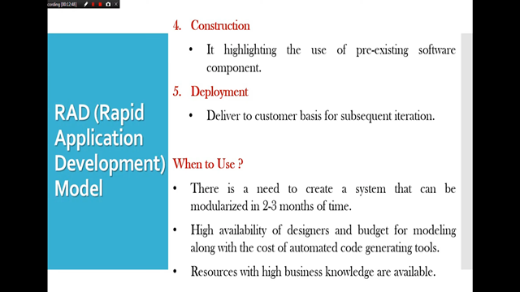
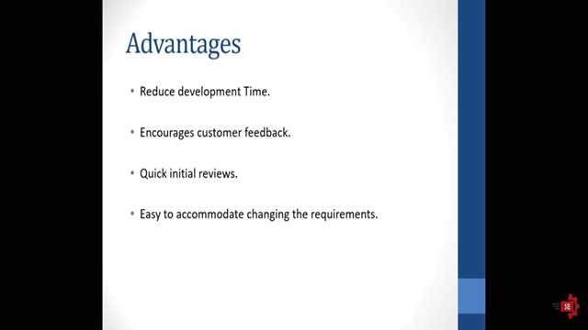
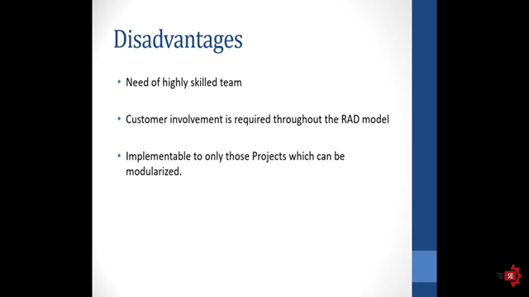

7.V-Model
V-Model also referred to as the Verification and Validation Model. In this, each phase of SDLC must complete before the next phase starts. It follows a sequential design process same as the waterfall model. Testing of the device is planned in parallel with a corresponding stage of development.

6.Spiral Model
The spiral model, initially proposed by Boehm in 1986, is an evolutionary software process model that couples the iterative feature of prototyping with the controlled and systematic aspects of the linear sequential model. It implements the potential for rapid development of new versions of the software. Using the spiral model, the software is developed in a series of incremental releases. During the early iterations, the additional release may be a paper model or prototype. During later iterations, more and more complete versions of the engineered system are produced.
The Spiral Model is shown in fig:

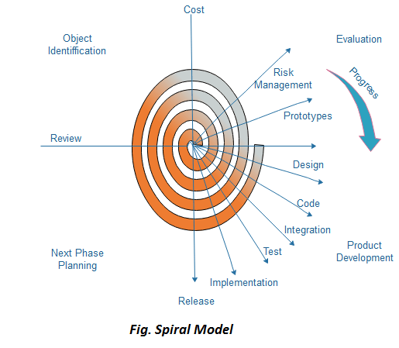

Each cycle in the spiral is divided into four parts:
Objective setting: Each cycle in the spiral starts with the identification of purpose for that cycle, the various alternatives that are possible for achieving the targets, and the constraints that exists.
Risk Assessment and reduction: The next phase in the cycle is to calculate these various alternatives based on the goals and constraints. The focus of evaluation in this stage is located on the risk perception for the project.
Development and validation: The next phase is to develop strategies that resolve uncertainties and risks. This process may include activities such as benchmarking, simulation, and prototyping.
Planning: Finally, the next step is planned. The project is reviewed, and a choice made whether to continue with a further period of the spiral. If it is determined to keep, plans are drawn up for the next step of the project.
The development phase depends on the remaining risks. For example, if performance or user-interface risks are treated more essential than the program development risks, the next phase may be an evolutionary development that includes developing a more detailed prototype for solving the risks.
The risk-driven feature of the spiral model allows it to accommodate any mixture of a specification-oriented, prototype-oriented, simulation-oriented, or another type of approach. An essential element of the model is that each period of the spiral is completed by a review that includes all the products developed during that cycle, including plans for the next cycle. The spiral model works for development as well as enhancement projects.

When to use Spiral Model?
- When deliverance is required to be frequent.
- When the project is large
- When requirements are unclear and complex
- When changes may require at any time
- Large and high budget projects

Advantages
- High amount of risk analysis
- Useful for large and mission-critical projects.

Disadvantages
- Can be a costly model to use.
- Risk analysis needed highly particular expertise
- Doesn't work well for smaller projects.

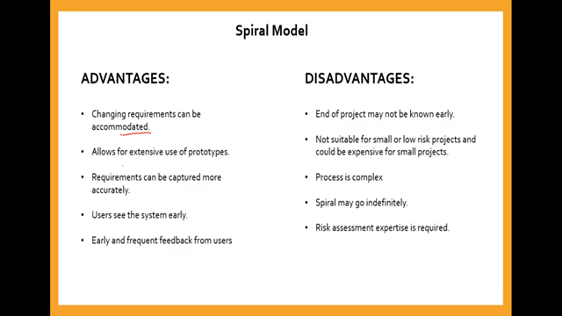
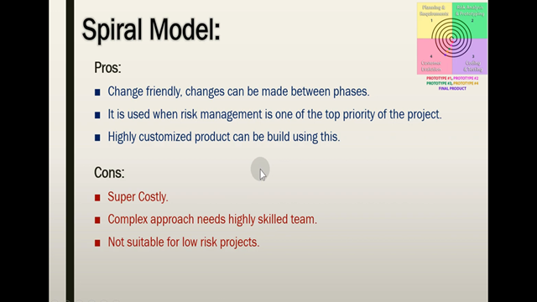

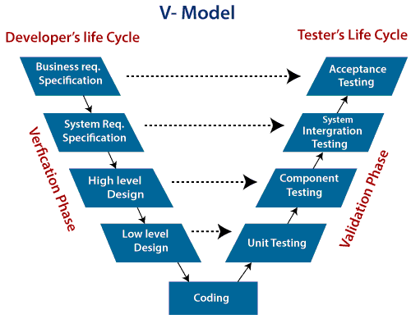
Verification: It involves a static analysis method (review) done without executing code. It is the process of evaluation of the product development process to find whether specified requirements meet.
Validation: It involves dynamic analysis method (functional, non-functional), testing is done by executing code. Validation is the process to classify the software after the completion of the development process to determine whether the software meets the customer expectations and requirements.
So V-Model contains Verification phases on one side of the Validation phases on the other side. Verification and Validation process is joined by coding phase in V-shape. Thus it is known as V-Model.
There are the various phases of Verification Phase of V-model:
- Business requirement analysis: This is the first step where product requirements understood from the customer's side. This phase contains detailed communication to understand customer's expectations and exact requirements.
- System Design: In this stage system engineers analyze and interpret the business of the proposed system by studying the user requirements document.
- Architecture Design: The baseline in selecting the architecture is that it should understand all which typically consists of the list of modules, brief functionality of each module, their interface relationships, dependencies, database tables, architecture diagrams, technology detail, etc. The integration testing model is carried out in a particular phase.
- Module Design: In the module design phase, the system breaks down into small modules. The detailed design of the modules is specified, which is known as Low-Level Design
- Coding Phase: After designing, the coding phase is started. Based on the requirements, a suitable programming language is decided. There are some guidelines and standards for coding. Before checking in the repository, the final build is optimized for better performance, and the code goes through many code reviews to check the performance.
There are the various phases of Validation Phase of V-model:
- Unit Testing: In the V-Model, Unit Test Plans (UTPs) are developed during the module design phase. These UTPs are executed to eliminate errors at code level or unit level. A unit is the smallest entity which can independently exist, e.g., a program module. Unit testing verifies that the smallest entity can function correctly when isolated from the rest of the codes/ units.
- Integration Testing: Integration Test Plans are developed during the Architectural Design Phase. These tests verify that groups created and tested independently can coexist and communicate among themselves.
- System Testing: System Tests Plans are developed during System Design Phase. Unlike Unit and Integration Test Plans, System Tests Plans are composed by the client?s business team. System Test ensures that expectations from an application developer are met.
- Acceptance Testing: Acceptance testing is related to the business requirement analysis part. It includes testing the software product in user atmosphere. Acceptance tests reveal the compatibility problems with the different systems, which is available within the user atmosphere. It conjointly discovers the non-functional problems like load and performance defects within the real user atmosphere.

When to use V-Model?
- When the requirement is well defined and not ambiguous.
- The V-shaped model should be used for small to medium-sized projects where requirements are clearly defined and fixed.
- The V-shaped model should be chosen when sample technical resources are available with essential technical expertise.

Advantage (Pros) of V-Model:
- Easy to Understand.
- Testing Methods like planning, test designing happens well before coding.
- This saves a lot of time. Hence a higher chance of success over the waterfall model.
- Avoids the downward flow of the defects.
- Works well for small plans where requirements are easily understood.

Disadvantage (Cons) of V-Model:
- Very rigid and least flexible.
- Not a good for a complex project.
- Software is developed during the implementation stage, so no early prototypes of the software are produced.
- If any changes happen in the midway, then the test documents along with the required documents, has to be updated.

