Unit-3

Human beings are good at understanding, reasoning and interpreting knowledge. And using this knowledge, they are able to perform various actions in the real world. But how do machines perform the same?
You will learn about Knowledge Representation in AI and how it helps the machines perform reasoning and interpretation using Artificial Intelligence in the following sequence

- What is Knowledge Representation?
- Different Types of Knowledge
- Cycle of Knowledge Representation
- What is the relation between Knowledge & Intelligence?
- Techniques of Knowledge Representation
- Approaches to Knowledge Representation with Example

What is Knowledge Representation?

Knowledge Representation in AI describes the representation of knowledge. Basically, it is a study of how the beliefs, intentions, and judgments of an intelligent agent can be expressed suitably for automated reasoning. One of the primary purposes of Knowledge Representation includes modeling intelligent behavior for an agent.
Knowledge Representation and Reasoning (KR, KRR) represents information from the real world for a computer to understand and then utilize this knowledge to solve complex real-life problems like communicating with human beings in natural language. Knowledge representation in AI is not just about storing data in a database, it allows a machine to learn from that knowledge and behave intelligently like a human being.

The different kinds of knowledge that need to be represented in AI include:
- Objects
- Events
- Performance
- Facts
- Meta-Knowledge
- Knowledge-base
let’s move on and know about the different types of Knowledge.

Different Types of Knowledge
There are 5 types of Knowledge such as:

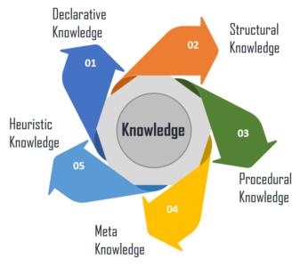
. Declarative Knowledge – It includes concepts, facts, and objects and expressed in a declarative sentence.
- Structural Knowledge – It is a basic problem-solving knowledge that describes the relationship between concepts and objects.
- Procedural Knowledge – This is responsible for knowing how to do something and includes rules, strategies, procedures, etc.
- Meta Knowledge – Meta Knowledge defines knowledge about other types of Knowledge.
- Heuristic Knowledge – This represents some expert knowledge in the field or subject.
These are the important types of Knowledge Representation in AI. Now, let’s have a look at the cycle of knowledge representation and how it works.

Cycle of Knowledge Representation in AI
Artificial Intelligent Systems usually consist of various components to display their intelligent behavior. Some of these components include:
- Perception
- Learning
- Knowledge Representation & Reasoning
- Planning
- Execution
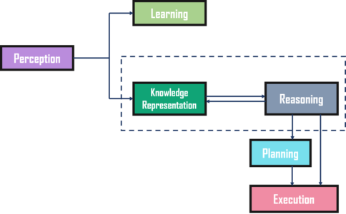
Here is an example to show the different components of the system and how it works:

Example

The above diagram shows the interaction of an AI system with the real world and the components involved in showing intelligence.

- The Perception component retrieves data or information from the environment. with the help of this component, you can retrieve data from the environment, find out the source of noises and check if the AI was damaged by anything. Also, it defines how to respond when any sense has been detected.
- Then, there is the Learning Component that learns from the captured data by the perception component. The goal is to build computers that can be taught instead of programming them. Learning focuses on the process of self-improvement. In order to learn new things, the system requires knowledge acquisition, inference, acquisition of heuristics, faster searches, etc.
- The main component in the cycle is Knowledge Representation and Reasoning which shows the human-like intelligence in the machines. Knowledge representation is all about understanding intelligence. Instead of trying to understand or build brains from the bottom up, its goal is to understand and build intelligent behavior from the top-down and focus on what an agent needs to know in order to behave intelligently. Also, it defines how automated reasoning procedures can make this knowledge available as needed.
- The Planning and Execution components depend on the analysis of knowledge representation and reasoning. Here, planning includes giving an initial state, finding their preconditions and effects, and a sequence of actions to achieve a state in which a particular goal holds. Now once the planning is completed, the final stage is the execution of the entire process.
So, these are the different components of the cycle of Knowledge Representation in AI.

Relationship between knowledge and intelligence

What is the Relation between Knowledge & Intelligence?
In the real world, knowledge plays a vital role in intelligence as well as creating artificial intelligence. It demonstrates the intelligent behavior in AI agents or systems. It is possible for an agent or system to act accurately on some input only when it has the knowledge or experience about the input.
Let’s take an example to understand the relationship:

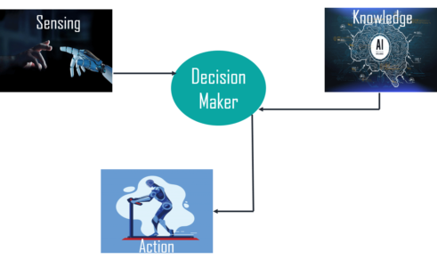
In this example, there is one decision-maker whose actions are justified by sensing the environment and using knowledge. But, if we remove the knowledge part here, it will not be able to display any intelligent behavior.

Techniques of Knowledge Representation in AI
There are four techniques of representing knowledge such as:

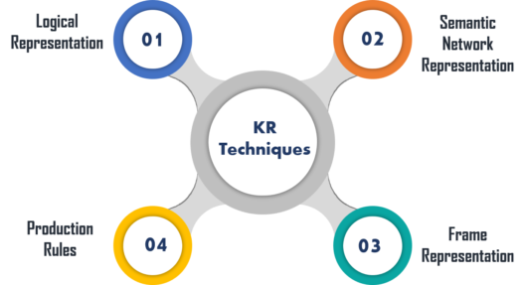

Logical Representation
Logical representation is a language with some definite rules which deal with propositions and has no ambiguity in representation. It represents a conclusion based on various conditions and lays down some important communication rules. Also, it consists of precisely defined syntax and semantics which supports the sound inference. Each sentence can be translated into logics using syntax and semantics.

Syntax | Semantics
- It decides how we can construct legal sentences in logic.  - It determines which symbol we can use in knowledge representation.  - Also, how to write those symbols. | - Semantics are the rules by which we can interpret the sentence in the logic.  - It assigns a meaning to each sentence.

Advantages:
- Logical representation helps to perform logical reasoning.
- This representation is the basis for the programming languages.
Disadvantages:
- Logical representations have some restrictions and are challenging to work with.
- This technique may not be very natural, and inference may not be very efficient.

Semantic Network Representation
Semantic networks work as an alternative of predicate logic for knowledge representation. In Semantic networks, you can represent your knowledge in the form of graphical networks. This network consists of nodes representing objects and arcs which describe the relationship between those objects. Also, it categorizes the object in different forms and links those objects.
This representation consist of two types of relations:
- IS-A relation (Inheritance)
- Kind-of-relation
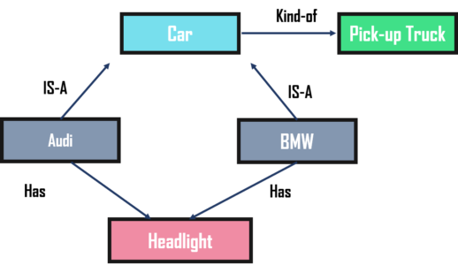

Advantages:
- Semantic networks are a natural representation of knowledge.
- Also, it conveys meaning in a transparent manner.
- These networks are simple and easy to understand.
Disadvantages:
- Semantic networks take more computational time at runtime.
- Also, these are inadequate as they do not have any equivalent quantifiers.
- These networks are not intelligent and depend on the creator of the system.

Frame Representation
A frame is a record like structure that consists of a collection of attributes and values to describe an entity in the world. These are the AI data structure that divides knowledge into substructures by representing stereotypes situations. Basically, it consists of a collection of slots and slot values of any type and size. Slots have names and values which are called facets.
Advantages:
- It makes the programming easier by grouping the related data.
- Frame representation is easy to understand and visualize.
- It is very easy to add slots for new attributes and relations.
- Also, it is easy to include default data and search for missing values.
Disadvantages:
- In frame system inference, the mechanism cannot be easily processed.
- The inference mechanism cannot be smoothly proceeded by frame representation.
- It has a very generalized approach.

Production Rules
In production rules, agent checks for the condition and if the condition exists then production rule fires and corresponding action is carried out. The condition part of the rule determines which rule may be applied to a problem. Whereas, the action part carries out the associated problem-solving steps. This complete process is called a recognize-act cycle.
The production rules system consists of three main parts:
- The set of production rules
- Working Memory
- The recognize-act-cycle
Advantages:
- The production rules are expressed in natural language.
- The production rules are highly modular and can be easily removed or modified.
Disadvantages:
- It does not exhibit any learning capabilities and does not store the result of the problem for future uses.
- During the execution of the program, many rules may be active. Thus, rule-based production systems are inefficient.
So, these were the important techniques for Knowledge Representation in AI. Now, let’s have a look at the requirements for these representations.

Approaches to Knowledge Representation in AI
There are different approaches to knowledge representation such as:

1. Simple Relational Knowledge
It is the simplest way of storing facts which uses the relational method. Here, all the facts about a set of the object are set out systematically in columns. Also, this approach of knowledge reprezsentation is famous in database systems where the relationship between different entities is represented. Thus, there is little opportunity for inference.
Example:
Name | Age | Emp ID
John | 25 | 100071
Amanda | 23 | 100056
Sam | 27 | 100042
This is an example of representing simple relational knowledge.

2. Inheritable Knowledge
In the inheritable knowledge approach, all data must be stored into a hierarchy of classes and should be arranged in a generalized form or a hierarchal manner. Also, this approach contains inheritable knowledge which shows a relation between instance and class, and it is called instance relation. In this approach, objects and values are represented in Boxed nodes.
Example:
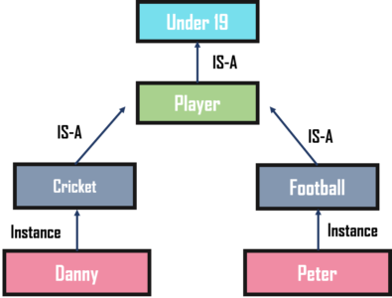

3. Inferential Knowledge
The inferential knowledge approach represents knowledge in the form of formal logic. Thus, it can be used to derive more facts. Also, it guarantees correctness.
Example:
Statement 1: John is a cricketer.
Statement 2: All cricketers are athletes.
Then it can be represented as;
Cricketer(John)
∀x = Cricketer (x) ———-> Athelete (x)s
These were some of the approaches to knowledge representation in AI along with example.

